INTRODUCTION

The Electrical Power System (EPS) is a fundamental subsystem for any satellite, serving as its primary energy lifeline. Its core responsibility involves harvesting energy, converting it into a usable electrical form, and then distributing this power reliably to all other onboard subsystems and payloads. This continuous provision of power is essential for the satellite's effective and uninterrupted operation throughout its mission duration.

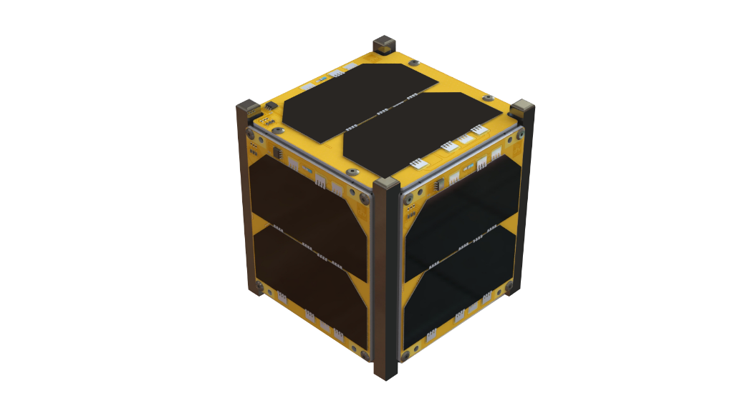

Figure 1: 1U CubeSat with body-mounted solar arrays

Satellites primarily derive their power from a combination of photovoltaic (PV) solar panels and rechargeable batteries. Solar panels are engineered to convert incident sunlight directly into electrical current, acting as the satellite's primary power generators. The batteries function as crucial energy reservoirs, storing excess power and providing continuous supply during periods when direct solar energy is unavailable. Such periods include orbital eclipses, the initial launch phase before solar panel deployment, or unforeseen emergency scenarios.

The operational rhythm of the EPS is linked to the satellite's orbital mechanics. During the "sun phase" of an orbit, when the satellite is illuminated by the sun, the solar panels are actively generating power. This generated power simultaneously fulfils the satellite's immediate operational loads and charges the onboard energy storage system. As the satellite transitions into an "eclipse phase" and enters the Earth's shadow, solar power generation ceases. At this point, the stored energy from the batteries takes over, ensuring the satellite's continued functionality. This cyclical demand necessitates that the batteries undergo constant discharge and recharge cycles, a particularly pronounced characteristic for satellites in Low Earth Orbit (LEO), which can experience eclipse durations of up to 36 minutes within a typical 92-minute orbital period.

The EPS is structured around two main units: the power generation unit (solar panels/arrays) and the energy storage unit (batteries), both meticulously managed by a sophisticated power control and distribution system.

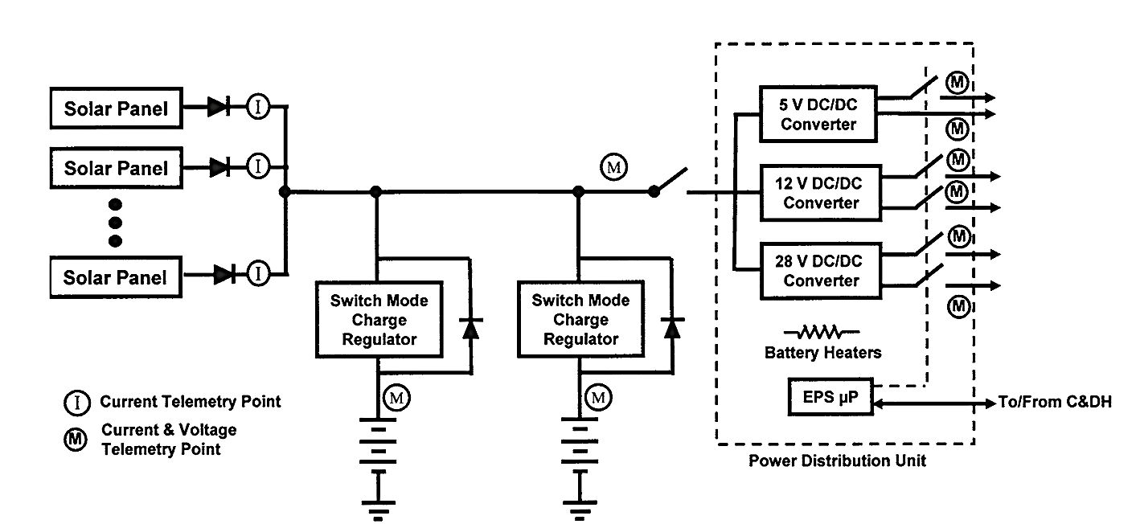

Figure 2: Typical Electrical Power Subsystem Block Diagram

**Core Components of a Satellite EPS**

1. **Power Generation Subsystem (Solar Arrays)**

Spacecraft primarily generate electrical power through photovoltaic (PV) solar panels, which convert sunlight into electricity.

**Solar Cell Types**

|  |  |  |  |
| --- | --- | --- | --- |
| Technology | Efficiency | Degradation | Applications |
| Silicon | ~12% | 5-10%/year | Historical, ISS |
| Multi-junction GaAs | >32% | <1%/year | Modern spacecraft |

**Efficiency and Degradation**

Solar panel efficiency inevitably degrades over time due to prolonged exposure to various forms of ionizing radiation prevalent in space. These include particles from Earth's radiation, galactic cosmic rays, solar wind, and solar flares. The rate of this degradation is highly dependent on the specific solar cell technology employed and the spacecraft's particular orbital location. For instance, solar panels with borosilicate glass coverings may experience an efficiency loss of 5-10% per year, whereas those utilizing advanced coverings like fused silica and lead glasses can reduce this loss to less than 1% per year.Temperature also plays a significant role in power production; as ambient temperature rises, the solar cell's open circuit voltage decreases, which directly affects the Maximum Power Point (MPP).

To maximize power generation per unit mass, spacecraft solar panels use densely packed solar cells covering nearly 100% of the sun-facing area. These cells are interconnected in series and parallel configurations and mounted on sturdy substrates like PCBs, CFRPs, or aluminium honeycomb panels.

**Body-Mounted vs. Deployable Arrays:**

Body-mounted panels are suitable for low-power CubeSats. Deployable arrays are needed for higher power missions, offering sun-tracking capabilities for optimal energy absorption but requiring complex mechanisms. Modern deployable arrays integrate additional functions (antennas, sensors) and can fold into ultra-thin profiles while delivering high power (e.g., 12W for a 1U CubeSat).

**Challenges & Mitigations:**

* **Shadowing** (obstruction by satellite components) can distort power output; solutions include active pointing, bypass diodes, and optimized series-parallel designs.
* **Design trade-offs:** Deployable arrays increase power but add mechanical complexity, failure risks, and thermal management challenges, especially in CubeSats with strict size/mass constraints.

**Orbit & Attitude Dependence:**

* Solar power generation depends on the satellite’s orbit (e.g., sun-synchronous orbits provide consistent power) and **attitude control** (tumbling reduces efficiency).
* The **EPS design must align with the ADCS capabilities** and mission orbit to ensure reliable power availability.

**Maximum Power Point Tracking (MPPT)**

To maximize the efficiency of the power generation unit, it is crucial to absorb the maximum possible power from the solar array. This is achieved by operating the solar array at its Maximum Power Point (MPP), a specific point on its voltage-power (P-V) curve.An MPPT tracker is employed to ensure that the solar array's operating point remains at its MPP, which can shift due to varying environmental conditions such as solar irradiance, temperature, and shadowing. MPPT systems typically utilize boost/buck converters controlled by an algorithm to optimize the power delivered to the load, thereby preventing "brown-outs" where the load attempts to draw more power than the PV array can supply.20 MPPT circuits are generally connected in series between the solar cells and the batteries.

1. **Energy Storage Subsystem**

Batteries are indispensable components within a satellite's EPS, serving to store excess power generated by solar panels during daylight hours and to supply power to the satellite during eclipse periods or when solar panel generation is insufficient to meet peak loads.

Batteries for space applications can be broadly categorized into primary (single-use) and secondary (rechargeable) types. Primary batteries are typically employed for short-duration missions. Silver-Zinc (AgZn) batteries, known for their high energy density and ability to deliver strong current pulses, notably powered critical systems in the Apollo program.4 Lithium-based primary batteries generally offer even higher energy density.4

Secondary, rechargeable batteries are the workhorses for longer-duration missions.Key types include:

* **Lithium-ion (Li-ion):** Currently ubiquitous and considered state-of-the-art for small spacecraft due to their high energy density (150-250 Wh/kg), low weight, and rechargeability.4 They offer flexibility in power management, exhibit a low self-discharge rate (5-15% per month), and are free from the "memory effect". Their optimal operating temperature range is typically between 20-40°C. Li-ion batteries are widely used in Mars rovers, LEO communication constellations, and Earth observation satellites.
* **Lithium Polymer (Li-Po):** A variation of Li-ion technology that utilizes a polymer electrolyte, offering a flexible form factor that is highly advantageous for small satellites and CubeSats with strict volume constraints. They share many benefits of Li-ion, including high energy density (150-200 Wh/kg) and low self-discharge.
* **Nickel-Hydrogen (NiH2):** Distinguished by exceptional cycle life (2000+ cycles, often exceeding 20,000 with minimal degradation) and high specific power (300-500 W/kg). They were historically used in the ISS and Hubble Telescope, making them ideal for long-design-life GEO satellites. However, they have limitations such as higher self-discharge, lower volumetric energy density, and the requirement for high-pressure hydrogen storage.
* **Nickel-Cadmium (NiCd):** Known for their robustness, reliability, and tolerance to harsh radiation environments and repeated deep discharge cycles.11 They possess a moderate energy density (50-80 Wh/kg). Their use in new designs has declined due to lower energy density compared to newer technologies and environmental concerns related to cadmium toxicity.

Several key parameters dictate the suitability of a battery for space applications:

1. Energy Density (Wh/kg): The amount of energy stored per unit mass, a critical factor for minimizing launch costs.
2. Specific Power (W/kg): The rate at which energy can be delivered or absorbed per unit mass.11
3. Cycle Life: The number of full discharge-recharge cycles a battery can undergo before its capacity significantly degrades.
4. Depth of Discharge (DOD): The percentage of the battery's total capacity that has been depleted. Higher DOD values (e.g., 80-90%) are beneficial in space applications if they do not lead to performance degradation.
5. Operating Temperature Range: The temperature range within which the battery can operate effectively and safely.
6. Self-Discharge Rate: The rate at which a battery loses its stored charge when not in use.
7. **Power Conditioning and Distribution**

The Power Management and Distribution (PMAD) system, often referred to as the Power Conditioning and Distribution Unit (PCDU), is a critical component of the EPS. Its primary role is to control the flow of power to the various spacecraft subsystems and instruments, ensuring stable and reliable delivery.

The Power Conditioning Unit (PCU) and Power Distribution Unit (PDU) perform distinct yet complementary functions within the satellite's EPS. The PCU is responsible for regulating the electrical output from both the solar panels and the battery. Its main function is to ensure a stable and consistent voltage and current are supplied to the rest of the satellite's subsystems. This regulation is crucial because power generated by solar panels can be highly variable due to factors like sunlight intensity and satellite orientation, and battery output can also fluctuate. The PDU, in turn, takes this conditioned power from the PCU and efficiently distributes it to the various subsystems and payloads onboard the satellite, acting as a central hub that directs the appropriate power to each component.

**DC-DC Converters and Voltage Regulation**

DC-DC converters are pivotal in satellite EPS for power conditioning and distribution, enabling the transformation, transmission, and storage of power within the satellite. Power harvested from solar panels is transformed using DC-DC converters before being stored and supplied to the satellite's onboard electronics.In the power distribution module, DC-DC converters regulate the main bus voltage to meet the specific demands of individual subsystems.Similarly, the battery storage module relies on DC-DC converters for precise charge and discharge regulation, ensuring a continuous power supply, particularly during eclipses or when solar arrays cannot meet peak power demands.Depending on the application, galvanic isolation may be required at various power conversion phases, especially for secondary power distribution to payloads, to minimize noise and electromagnetic interference.

Satellite power designs are increasingly driven by the need for higher power levels while simultaneously controlling system mass and cost. This necessitates power electronic designs capable of managing high distribution currents, which often means increasing the bus voltage to minimize current and, consequently, the mass of the EPS. Typical bus voltages include 28 V DC for low-power satellites, and 70 V DC or 100 V DC for larger spacecraft.For electric propulsion systems, high-power Power Processing Units (PPUs) are required, consisting of highly efficient DC-DC converters that convert low-voltage, high-current satellite power into the high-voltage, low-current power needed by thrusters, while also providing isolation.

To ensure high reliability, Power Conditioning and Distribution Units (PCDUs) incorporate full redundancy and internal cross-strapping, operating in hot redundancy to maintain functionality even if a single component fails. Each module is self-sufficient, with minimal shared interfaces via a backplane to ensure failure isolation and functional segregation.

Employing Overcurrent Protection by using Latching Current Limiters (LCLs) to regulate and limit current to prevent damage from short circuits or overloads. They maintain stable current levels and control inrush current during power-up. A single module can support multiple LCLs (e.g., 24 channels), ensuring rapid fault isolation without disrupting the main power bus.

1. **Battery Management System (BMS)**

A Battery Management System (BMS) is an intelligent electronic device crucial for monitoring and managing the performance, use, and safety of a battery pack, particularly for lithium-ion batteries.Its primary role is to ensure the safe and optimal operation of the battery throughout its lifecycle. The BMS continuously monitors critical parameters such as the temperature, voltage, State of Health (SOH), and State of Charge (SOC) of each cell within the battery pack.

Modern BMS are capable of performing complex tasks beyond basic protection and monitoring. Key features often include:

1. Battery Monitoring: Continuous tracking of voltage, current, temperature, SOC, and SOH for each cell.
2. Battery Estimations: Algorithms to accurately estimate SOC and SOH, crucial for mission planning and power budgeting.
3. Battery Protection: Safeguards against overcharging, over-discharging, overcurrent, short circuits, and thermal runaway. This often includes hardware and software overcurrent protection for each power output channel.
4. Battery Balancing Techniques: Active or passive cell balancing to ensure uniform voltage and charge across all cells in a pack, preventing unbalanced cell conditions and maximizing usable capacity.
5. Diagnostics and Prognostics: Advanced capabilities to diagnose faults and predict remaining useful life, enabling proactive maintenance or operational adjustments.
6. Temperature Management: Integrated battery heaters and control functions to maintain the battery within its optimal operating temperature range, especially critical for Li-ion batteries.
7. Configurable Slew Rate: Support for configurable slew rates on power outputs to handle inrush currents of various loads.
8. Communication Interfaces: Support for standard communication protocols (e.g., CAN, UART/RS422) for interfacing with the On-Board Computer (OBC) and ground control.
9. Integrated Charger Circuit: Simplifies integration operations by providing a built-in charging capability.
10. Undervoltage Lockout: Protection by a main switch to prevent battery discharge below a safe minimum voltage.

**Architectural approaches for a 1U CubeSat EPS**

**Direct Energy Transfer (DET)**

In a DET architecture, the storage system and electrical loads are directly connected to the PV panels through series diodes.To manage excess PV power when the system is fully charged or connected to low loads, shunt regulators are typically installed in parallel with the PV arrays. This excess power is usually dissipated as heat within the CubeSat and discharged onto the PV panel via a resistor in the shunt regulator. DET is the simplest and most cost-effective option for radiation environments due to fewer components and higher reliability. However, its major drawback is the underutilization of the PV panel's power generation capacity, as it does not always operate at the maximum power point. A failure in the shunt regulator can also lead to mission failure.

**Peak Power Tracking (PPT)**

The PPT architecture utilizes a DC-DC converter-based design to perform Maximum Power Point Tracking (MPPT) across a wide range of operating conditions, including varying solar irradiance and PV panel temperatures. In this setup, a series regulator is typically placed between the load and the solar array. This technology is commonly used in CubeSats because of their limited power-generating capabilities due to their small size and restricted space for larger PV panels. MPPT can be implemented using either digital microcontrollers (MCUs) or analogue controllers. MCUs offer simplicity and tuning flexibility but are vulnerable to radiation damage, whereas discrete analogue controllers, though less efficient, are considered more reliable and can serve as primary or backup control.

**1U CubeSat Electrical Power System (EPS) Design**

**A. Power Generation: Solar Arrays**

For optimal power generation, deployable triple-junction Gallium Arsenide (GaAs) solar arrays are recommended. A fused silica cover glass should be applied to minimize radiation-induced degradation (<1% per year).

GaAs has:

1. High efficiency (30–39%), outperforming traditional silicon cells.
2. Superior radiation resistance, crucial for long-term missions.
3. Deployable configuration maximizes power output (~10–12W for a 1U CubeSat).

Configuration:

* 3–6 panels (e.g., 3-fold deployable design).
* Electrical arrangement: 3 cells in series per string (3S1P) to boost voltage.
* MPPT (Maximum Power Point Tracking) required to compensate for shadowing and thermal variations.

**B. DC-DC Converters (Power Conditioning)**

A synchronous buck/boost DC-DC converter is ideal for efficient power regulation.

Key Benefits:

* Converts variable solar input to stable bus voltages (3.3V, 5V, or 12V).
* Convertors with GaN technology improves efficiency, reduces size, and minimizes switching losses.
* Supports MPPT algorithms (Perturb & Observe or Incremental Conductance).

**C. Energy Storage**

Lithium-ion (Li-ion) or Lithium Polymer (Li-Po) batteries in a 2S2P configuration (7.4V nominal, 4 cells total) provide the best balance of energy density and reliability.

Advantages:

* High energy density (150–250 Wh/kg).
* Low self-discharge and long cycle life (~500–2000 cycles).
* Compact form factor, fitting CubeSat volume constraints.

**Capacity Sizing:** 20–30 Wh supports approx. 30 min eclipse at 1.5W average load.

**Battery Management System (BMS) Requirements:**

* State of Charge (SOC) & State of Health (SOH) monitoring.
* Cell balancing & overvoltage/current protection.
* **Thermal monitoring + heater** for extreme conditions.

**D. Current & Voltage Sensing**

Hall-effect or shunt-based sensors (e.g., Allegro ACS7xx, INA219/INA260) with I²C/SPI/analog outputs ensure accurate power monitoring. This is essential for MPPT, power budgeting, and fault detection. Hall-effect sensors provide isolation and low-power operation.

**E. Power Distribution Architecture**

A Peak Power Tracking (PPT) architecture is recommended, with optional hybrid DET+PPT for simplicity/reliability trade-offs.

Key Features:

* MPPT regulation between solar panels and battery.
* Latching Current Limiters (LCLs) for each output.
* Load prioritization & fault protection (low-voltage cutoff, RBF pin).
* Fault-tolerant startup (e.g., 30-minute delay post-deployment).